Digital Blood Bank management System

Team

1. Shubham S. Dange
2. Kiran R. Nimbal

SRS document

INTRODUCTION

1. Purpose:

The DBMS(Digital Blood Bank Management System) works hand in hand with the traditional system of blood donation, but in a digital way.The system is intended for those who wants to donate the blood and also for seekers who need emergency blood supply . The whole system is administered by blood bank administrator and

He is responsible for managing the appointments of donors as well as supply management for the seekers along with verification and payment management The system also intends to help the blood seekers and the donors to donate/get the blood online .

Scope:

The system allows the user to donate the blood,without any hassle and a crowd-free environment which is essential in these pandemic times especially, and also for the seekers ,be it individual or any hospitals/emergency trauma care centers , to get the blood in online way.

Definitions:

1. DBMS: Digital Blood Bank Management System
2. SRS: Software Requirement Specification

Overview:

The system provides online way for donating the blood ,as in these pandemic times, physical blood donation camps are not getting held. It also allows the seeker of the blood to get the blood at his convinient location,performing some steps without physically going to the blood bank.

Principle actors:

Three principle actors are:

1. the administrator
2. The donor
3. The seeker.

Description:

The proposed system primarily have three actors in its operation cycle.

1. The administrator (Blood Bank)
2. The donor
3. The seeker (individual/hospitals)
4. The admin side and its role:

The admin acts as a centralized controller of the system.He is responsible for:

1. Taking required information fro the Donor and appointing him a medical examiner for the blood test.
2. If the donor tests positive( healthy enough to donate blood ) collecting the donated blood and adding it to the inventory
3. Taking required information from the seeker and supplying the blood to the seeker.
4. Managing the inventory according to the daily donation and supply of the blood
5. Managing the payment from the seeker.

The donor and its role:

1. The donor requires to fill up his personal as well as medical information
2. Making the appointment for the blood test.
3. If healthy enough , going to the appointed location to donate the blood

The seeker and its role:

1. The seeker requires to fill up the details along with his location on witch the blood is required.
2. Making the payment for the purchase .

Technical requirements:

This system will work on client-Server architecture. It will require an internet server.The system should support some commonly used browser such as Chrome Firefox,Internet Explorer etc.

Interface Requirement :

Various interfaces for the system could be

1.Login Page

2.Registration form

There will be a screen displaying information about inventory and available blood related products like :

1. The blood arranged according to blood group.
2. The plasma
3. Separated platelets.

The donor may select the location and date for his blood test and get his appointment details .

The seeker may select his location,required product and proceed though the payment and get the payment details .

Hardware Interface:-

The System must run over the internet, All the hardware shall require to connect to internet will be hardware interface for the system.e.g. modem, WAN, LAN Specialized Server Infrastructure Hardware.

The system should use updated software for managing large amount of data so as to make it appear as single unit for end-user.The system should have proper clusters for backup.

Hardware requirements for insurance on internet will be same for both parties which are as follows:

-Processor:Dual Core

-RAM:2 GB

-Hard Disk:320 GB

Software Interface:-

-OS platform which supports JDK(Java) Like windows, mac, or Linux.

-JDK 1.8

-Eclipse/STS/Netbeans.

-MYSQL v5.6 or above.

-Tomcat 8.5 or above.

Tools and Technologies:-

The Digital Blood Bank Management System is a web application in Java. It’s using JSP, HTML, JavaScript, Bootstrap, CSS, Servlet, JDBC, MYSQL, Eclipse or STS tool, or Netbeans, and the tomcat server.

-It has HTML , CSS , BOOTSTRAP and/or ANGULAR to manage the front end.

-Servlet to manage the server-side request and response.

-MySQL with the workbench to manage the backend/Database.

-Tomcat Server to deploy the application.

-STS or Eclipse or Netbeans as an IDE to write and run the source code.

Performance Requirement:-

There is no performance requirement in this system, because the server request and response to client is totally based on internet connection of enduser.

Design Constrains:-

This system should be developed using Standard Web Page Development Tool , which conforms GUI standards such like HTML, XML, JSON,etc.

The system should support various RDMS and Cloud Technologies.

Use case diagram:

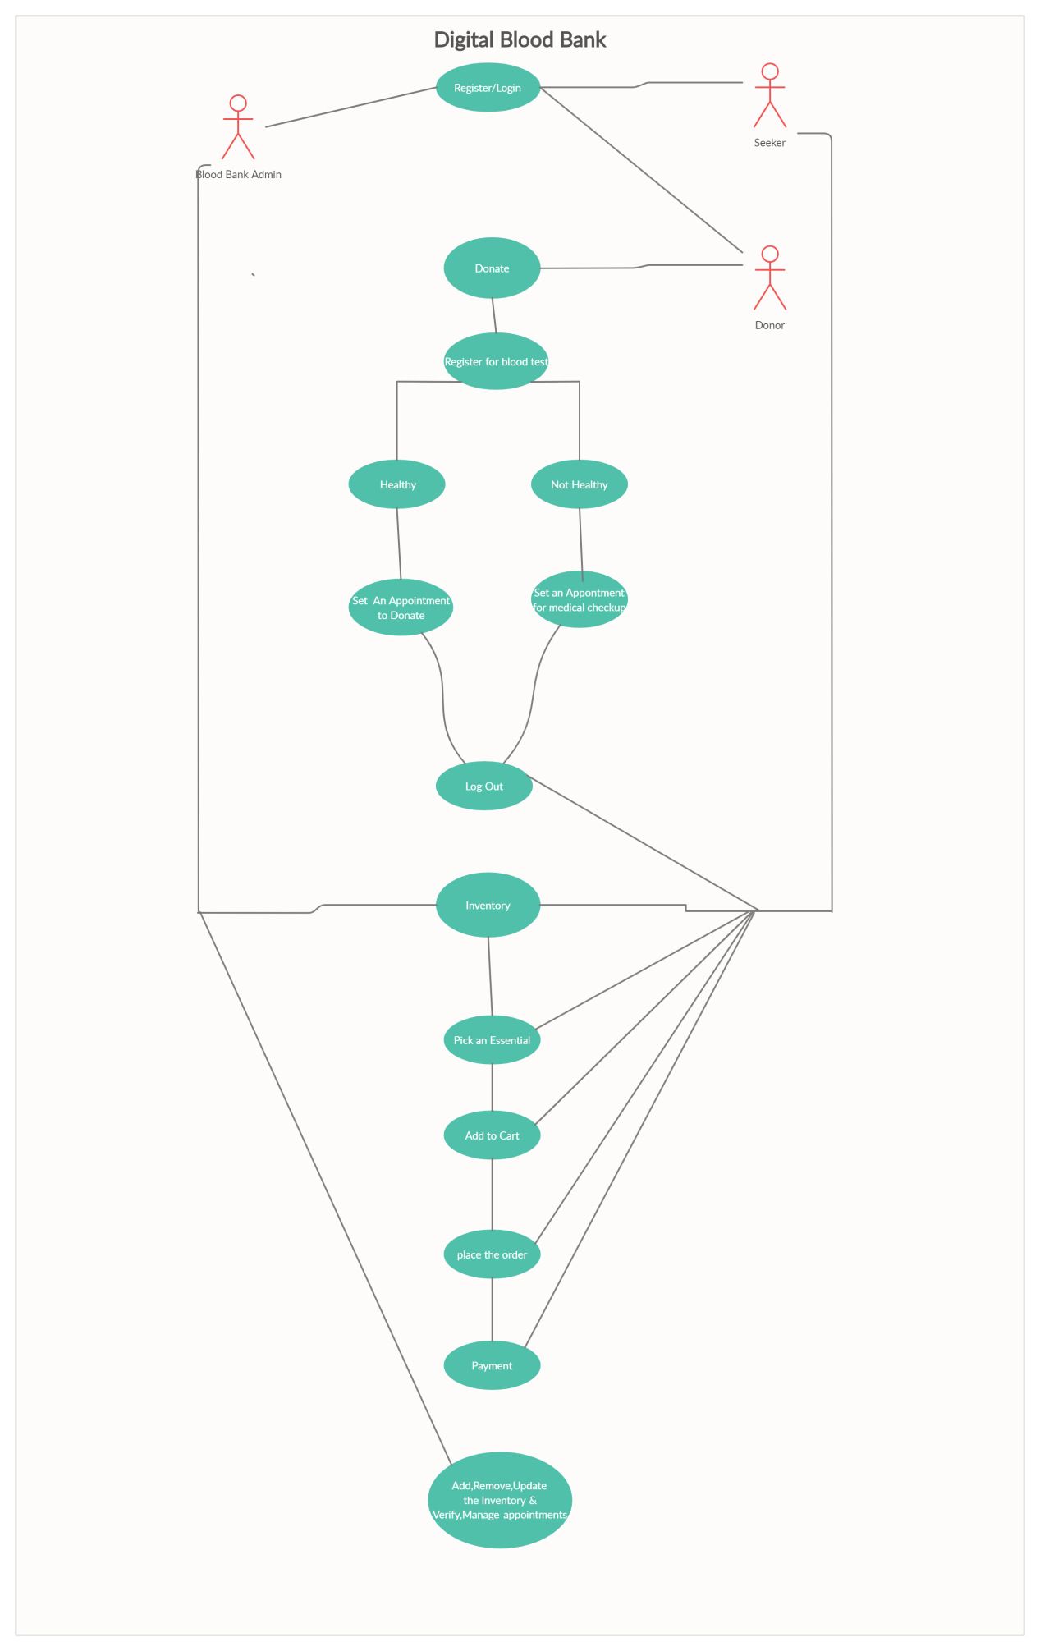

NON-Functional Requirements:

Following Non-Functional Requirements will be there in the insurance to the internet:

-Secure access to donor’s and seeker’s confidential data.

-24X7 availability.(MUST)

-Better component design to get better performance at peak time.

-Flexible service based architecture will be highly desirable for future extension.Non-Functional Requirements define system properties and constraints.

Various other Non-Functional Requirements are:

-Security

-Reliability

-Maintainability

-Portability

-Extensibility

-Reusability

-Compatibility

-Resource Utilization